Day 9:

Creating rest api with express JS and mongoose in MVC style (model view controller).

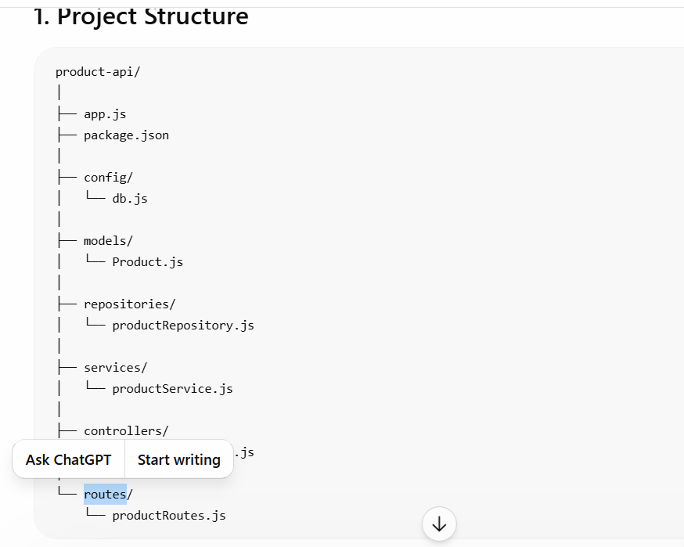

mkdir product-rest-api-mvc-style
npm init -y
npm install express mongoose

models : This folder contains model file which link to collection in mongo db. Mongoose module provide schema features (field name, data types and validation) using schema we can create the model.
repositories : this folder contains pure database logic using mongodb or mongoose module
service : this folder contains pure business logic. Before store the data in database or after retrieve data from database if you want to apply any business requirement base upon client requirement you can write inside service file.
Controller : this folder contains request and response code. Means which help to take the data from view technologies or rest api and pass the data to service layer. Base upon service layer response it send to different view or different format output.
router : express js provide router features which help to make request path and http methods. Base upon http method and path it will re-direct to particular controller functions.
config :: this folder contains configuration details. Example database connections.
dbConfig.js

app.js : this file load all requirement module, all any middleware if required, call dbConfig.js file to connect database, map main path of particular router, provide port number datails.

Post sample data
{
"pname": "Hard Disk",
"price": 12000,
"quantity": 50,
"category": "Electronics"
}

